**Module 3: Data Exchange and Data Formats**

Brad Hawk

Information Technology Dept, Arizona State University

IFT458: Middleware Programming & Database Security

Prof. Dinesh Sthapit

Due: 9/24/2022

**Module 3: Data Exchange and Data Formats**

**Figure 1**

*Screenshots after “Reusable components to create a composite component”*

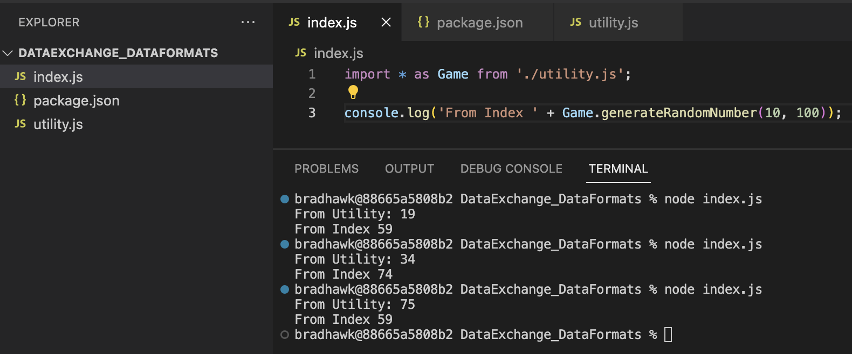

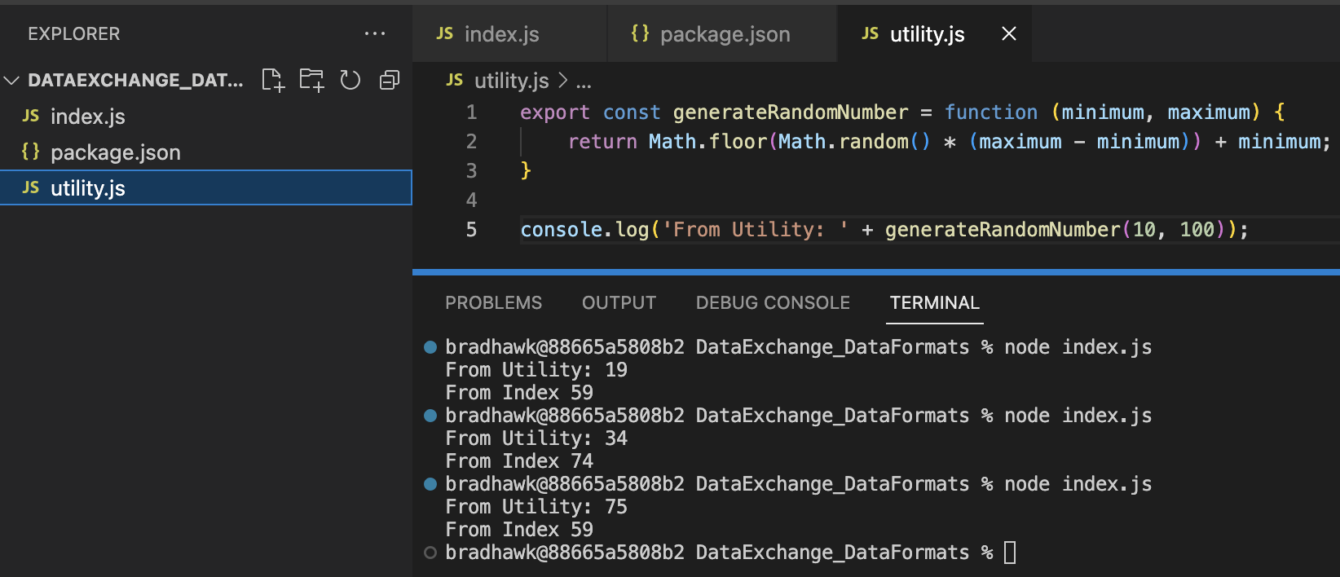

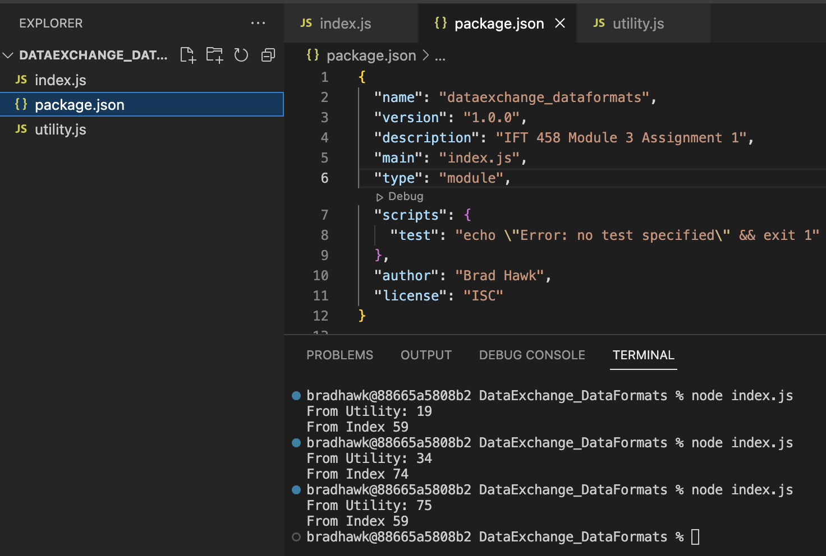

**Figure 2**

*Screenshot after “Using Importing External Modules (third-party modules)*

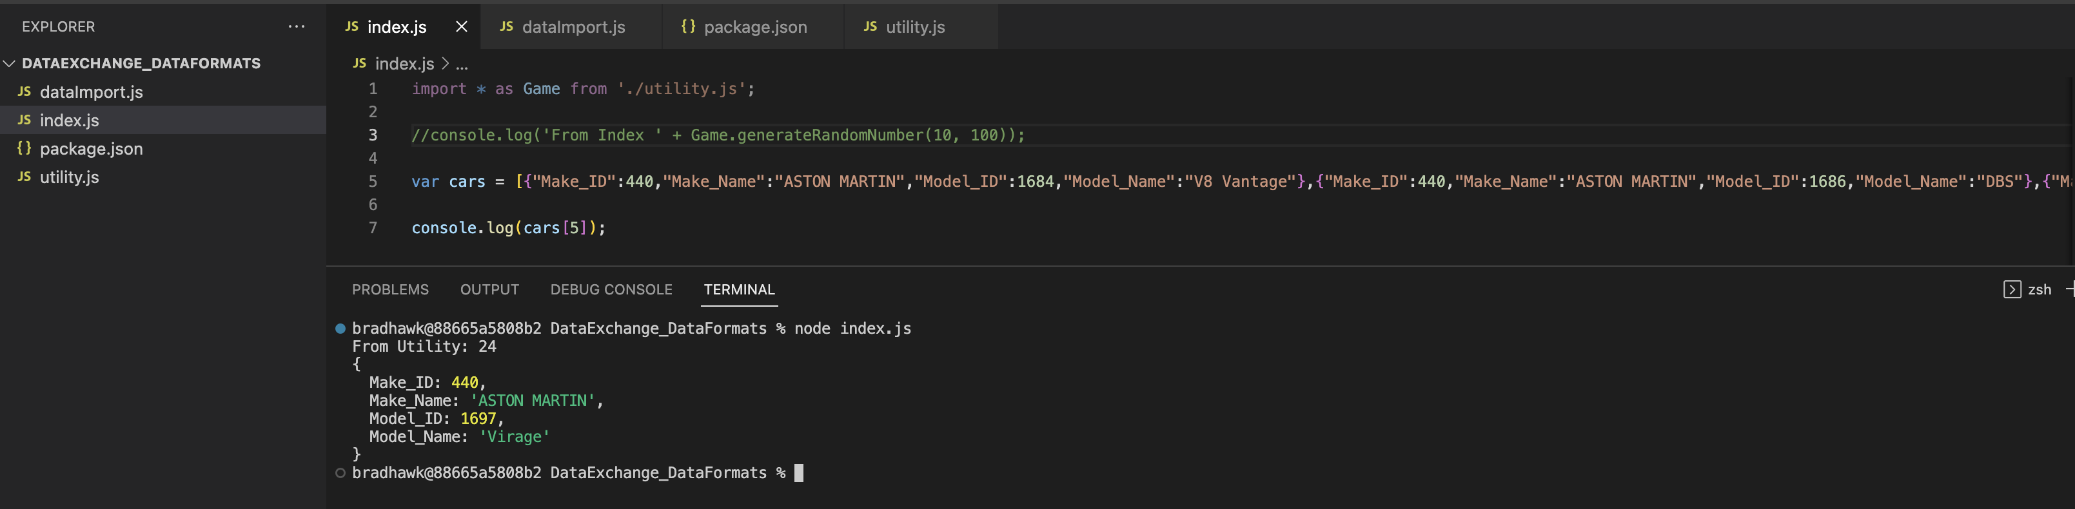

**Figure 3**

*Screenshot after “Data Formats and Data Exchange”*

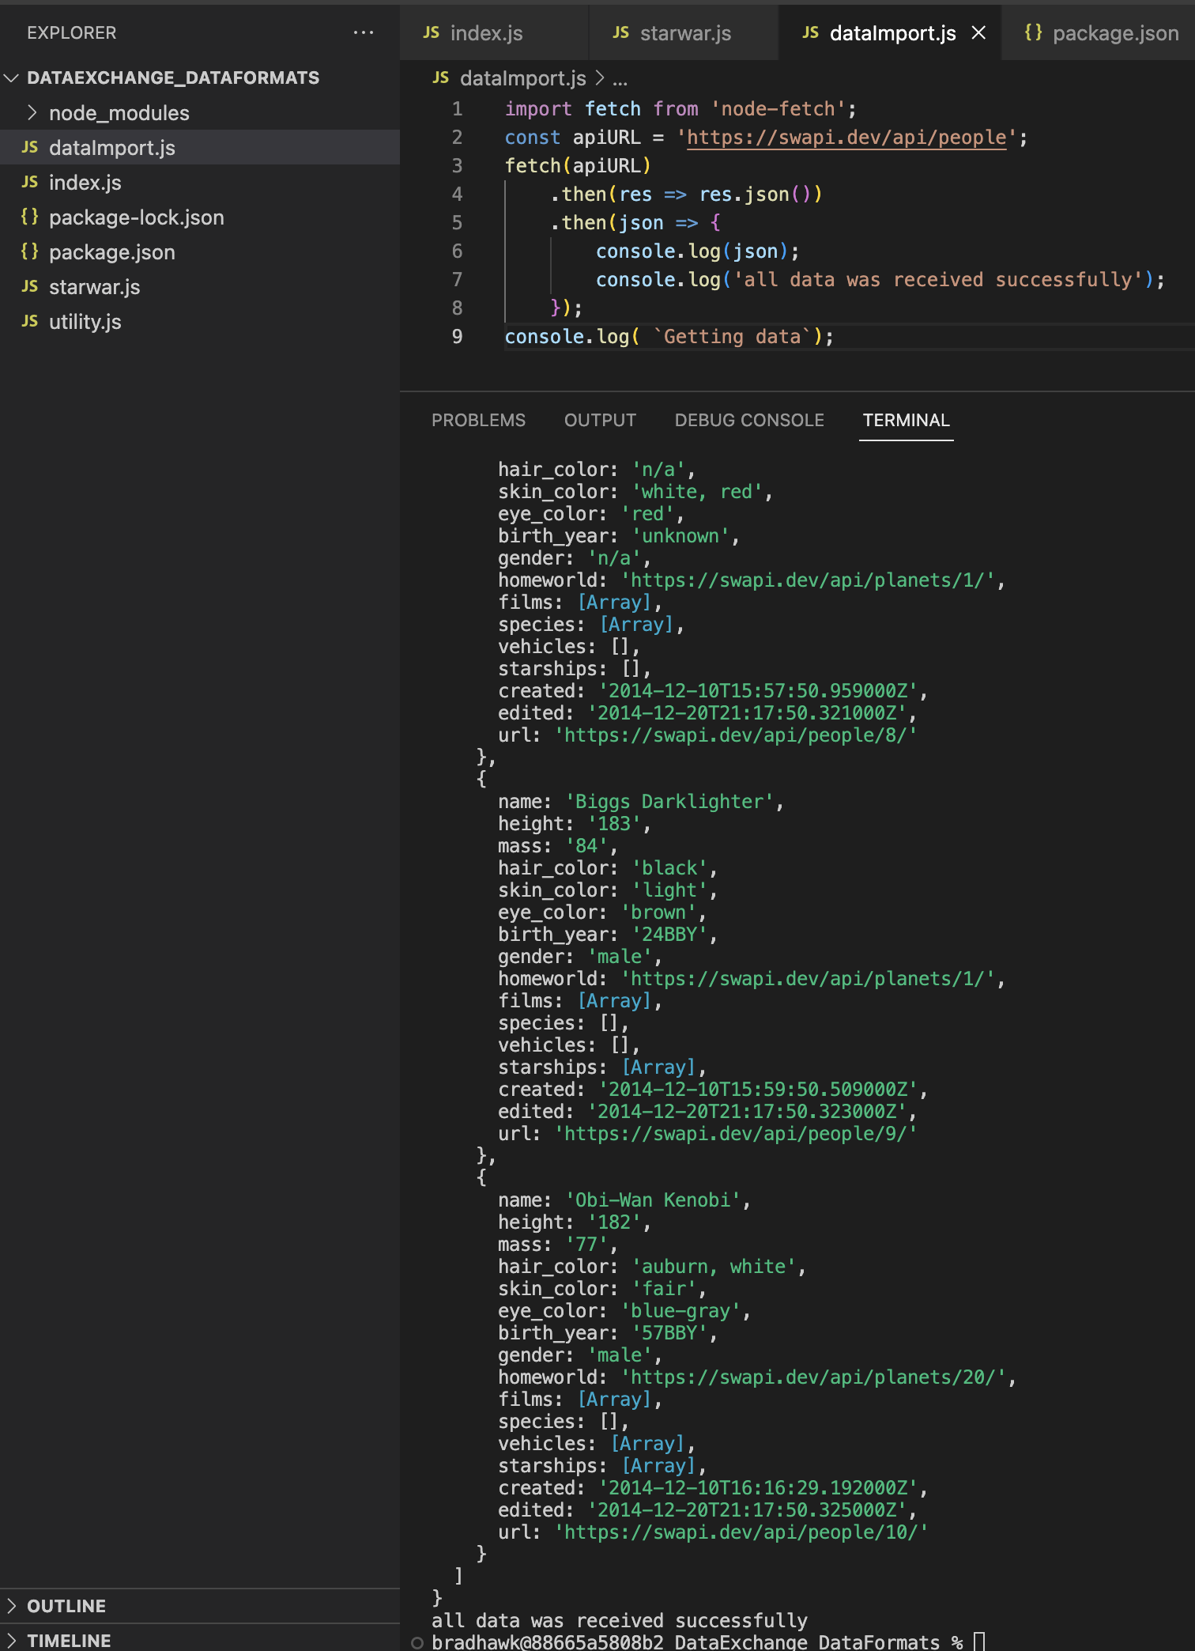

**Figure 4**

*Screenshot after “Content Negotiation”*

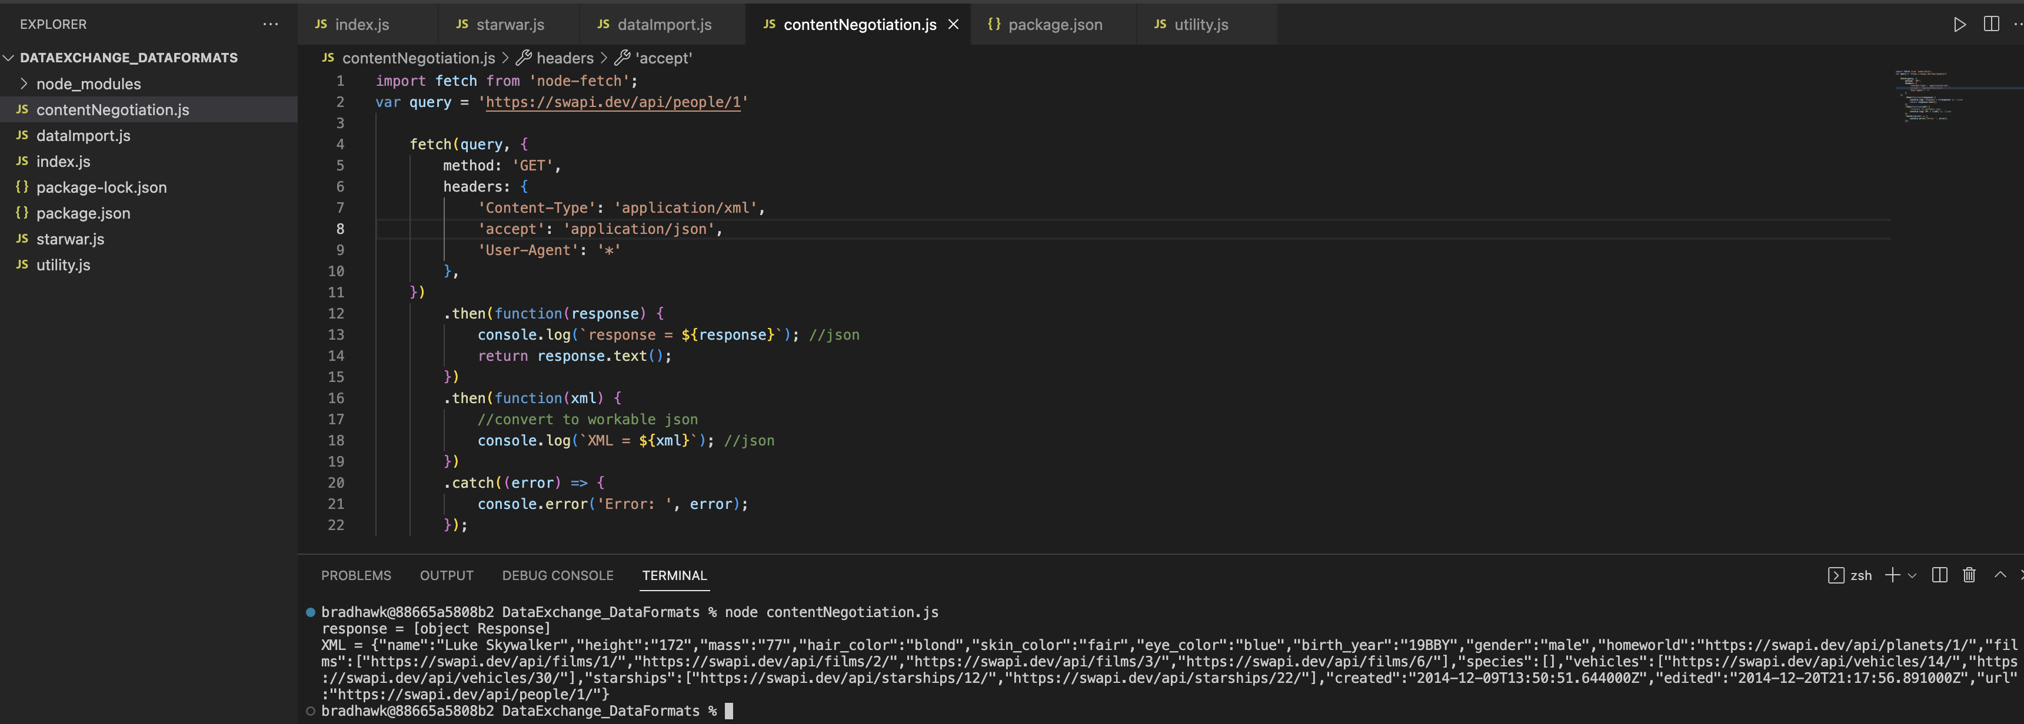

**References**

*References aren’t necessary for this assignment*